Name: NGO TUNG CHUONG
ID: s225586848

YouTube:
Opened loop | Closed loop
Square-case_1 | forward-backward-slow
Square-Case_2 | forward-backward-fast
 | turn-200 speed
 | turn-1000 speed
 | square-1
 | square-2

GitHub: https://github.com/NoXxChapter/SIT122---Robotics-Studio.git

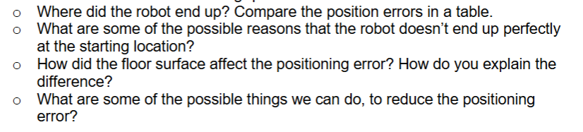
The robot’s end position usually scatters, lay around the but not back in the original position.
Comparison Table of Open Loop
Start position (cm) | End position (cm)
0 | 12
0 | 11
0 | 12
0 | 14

The robot’s end position usually scatters, lay around the but not back in the original position.
Comparison Table of Close Loop
Start position (cm) | End position (cm)
0 | 6
0 | 5
0 | 8
0 | 5

The return position from both loop case have a significant difference between each one. As we can observe that the close loop have a better result. Which have many reasons, but first must be the wait time allow the inertia to rest to almost zero, greatly reduced the error. But the major must be that with close loop, we measure a lot of information to calculate then execute. Which objectively superior than open loop, when it only blindly run without measure. And there are still numerous reasons behind but those two maybe the highlight ones gave us a good explanation of why close loop is better than open loop.

Inertia, floor surface (friction), dust, sand, rock, low/high battery,…

The reason why the floor surface affects the positioning error is first the material. Which with each type can make the interact between the wheels with the surface result in variety. The second were dust, rock, sand. Each can make either the wheel more slippery or roughly.

The easiest solution we can do to achieve the nearly perfect square is run on smooth surface with enough friction to make the wheel stick to floor. Another solution is to change the wheel, use a bigger one which can reduce the affections from external reasons to hardly noticeable.

Thanks to the guide provided by tutor Precise Motion guideline gave me a quick understand of these measure methods. With both case we have to calculate how many rotation per minute does a wheel(s) have to rotate to successfully execute the request.
First with straight line
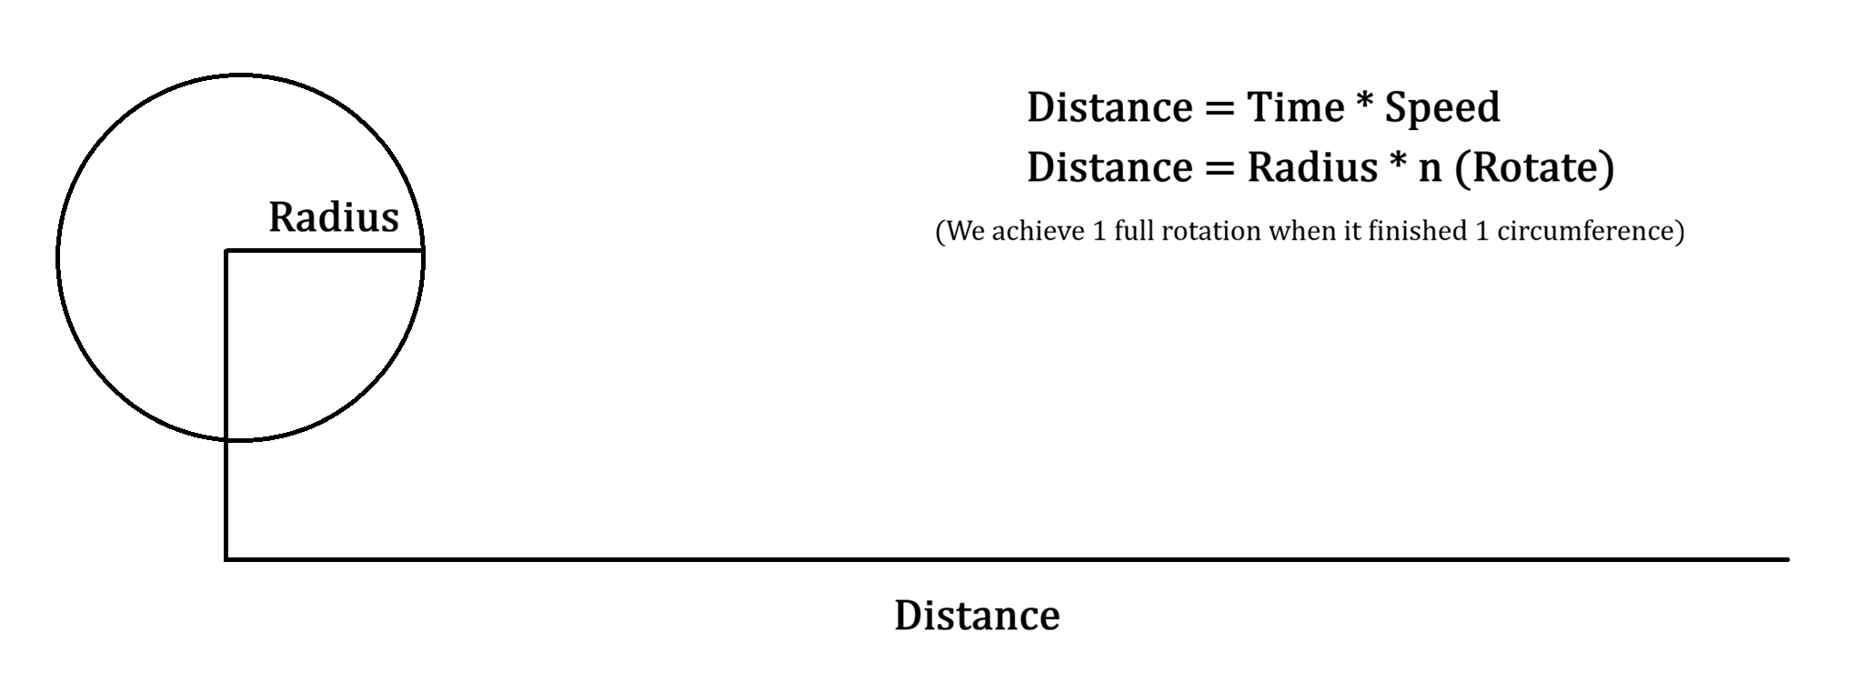
Last is turning
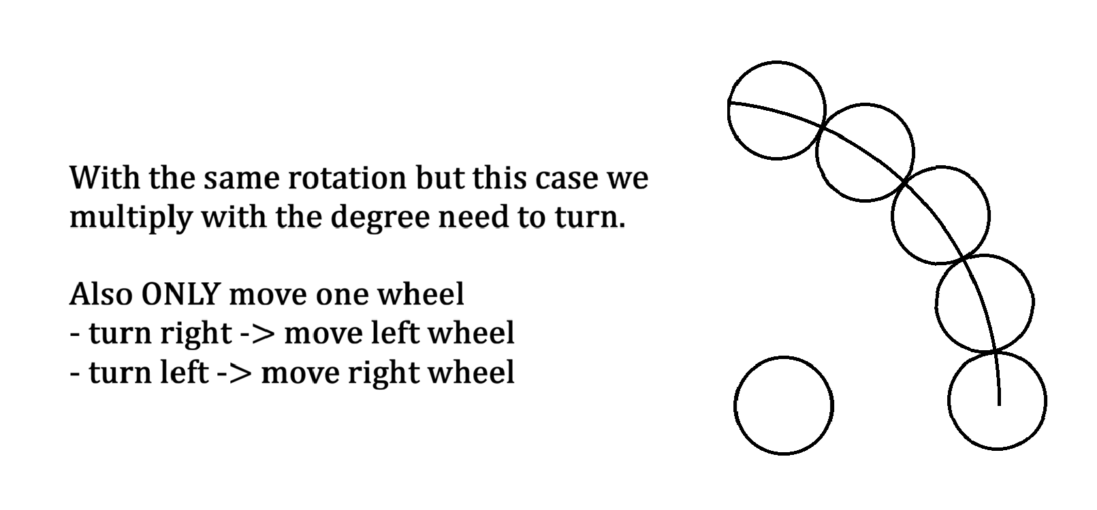

Opened Loop
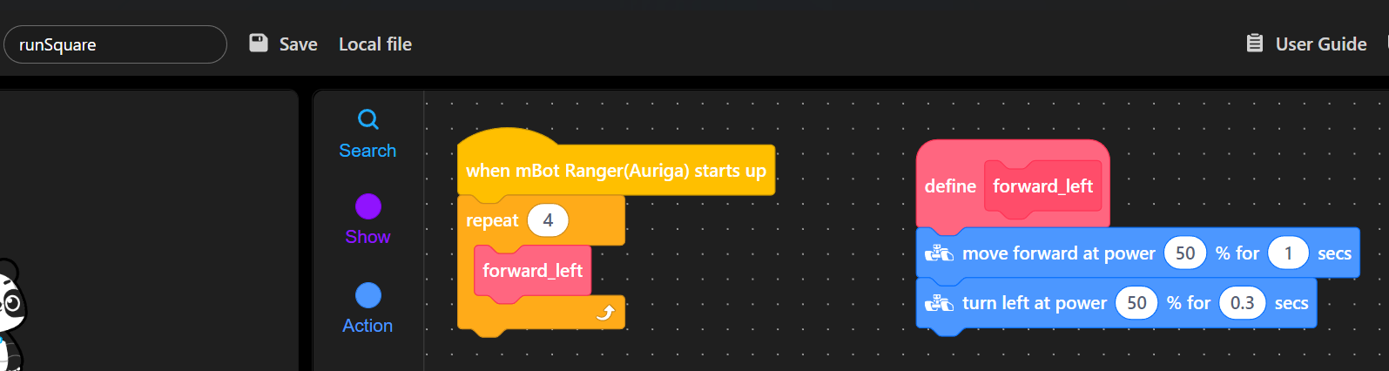
(open loop – square)

Closed Loop
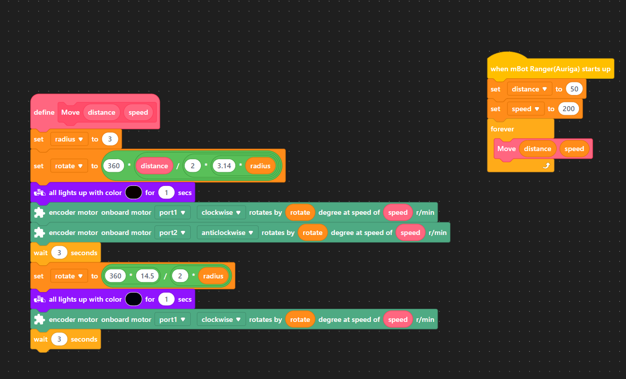
(closed loop – square code)
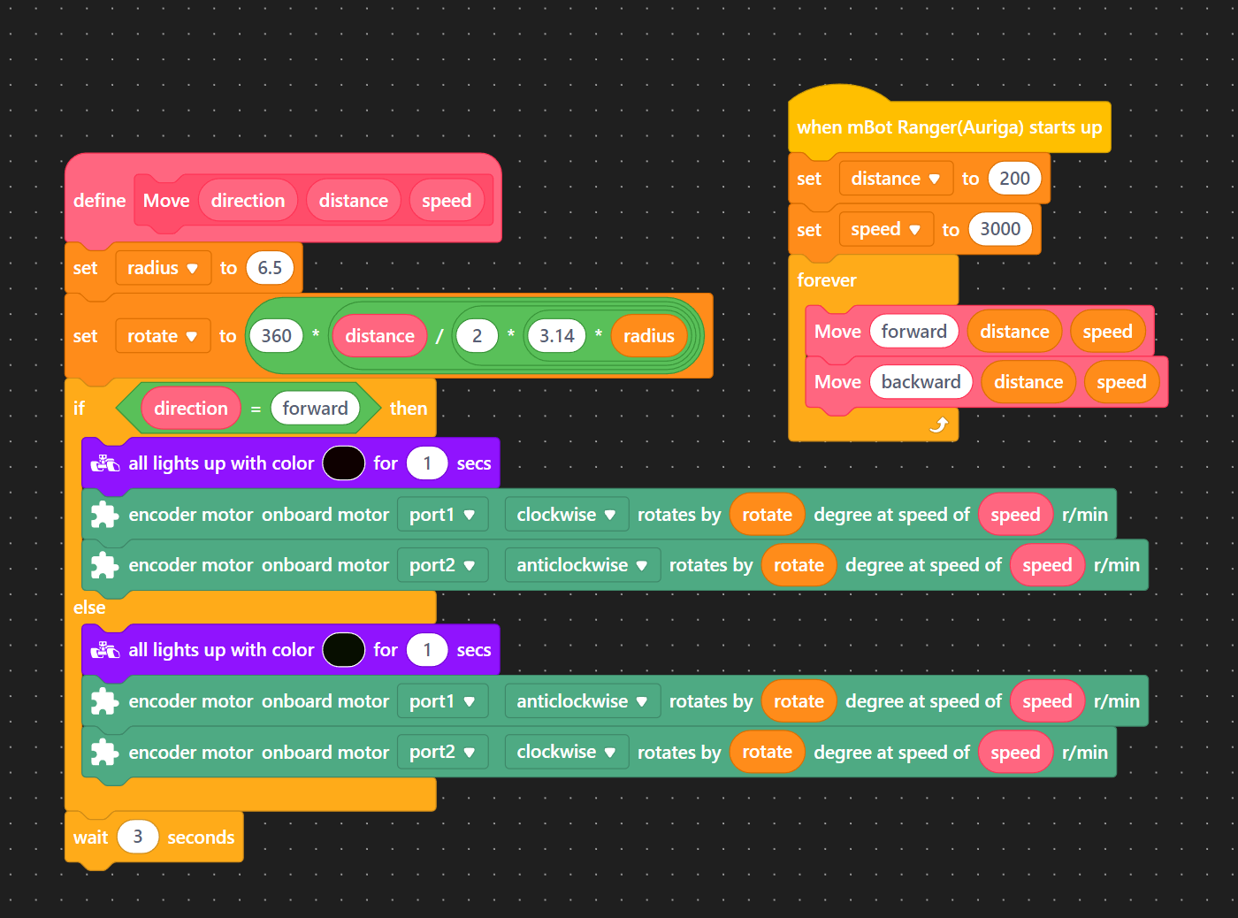
(closed loop – forward – backward)

